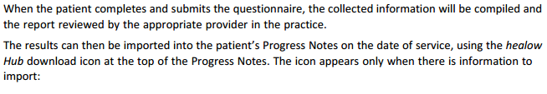
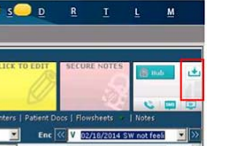
Once the response has been imported, refresh the Progress Notes to view the information.
Refresh Icon can be found at the bottom of the progress note
