On-Line Student Experience Evaluation
- Go to Nationwide Children’s Hospital Intranet - ANCHOR (available from every clinical workstation) before the end of your clinical experience at Nationwide Children’s Hospital.

- Select “Education & Training” from the tabs.

- Select “Professional Development” from the drop down menu.

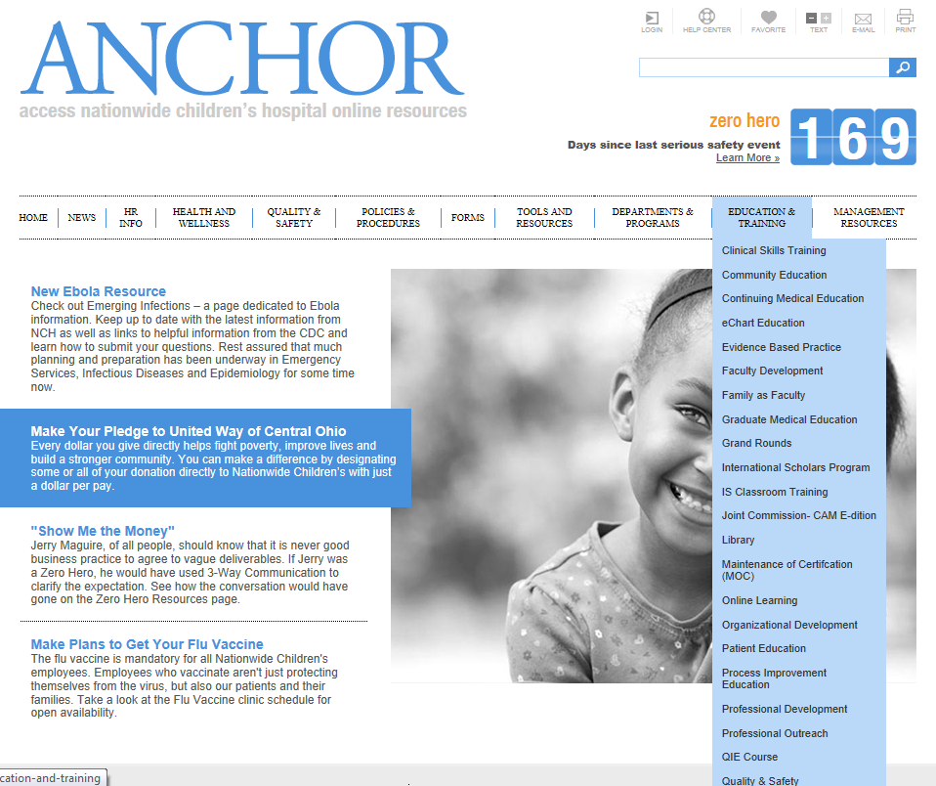

- Scroll to the bottom of the Professional Development page and click on Click here to access the evaluation database

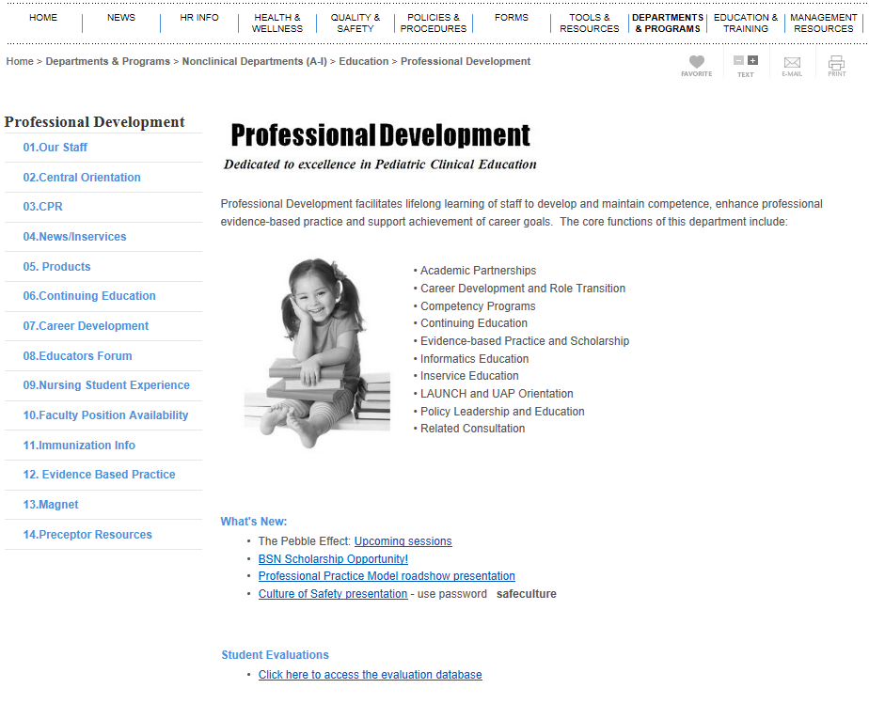

- Click on the link: Click here to take a class survey

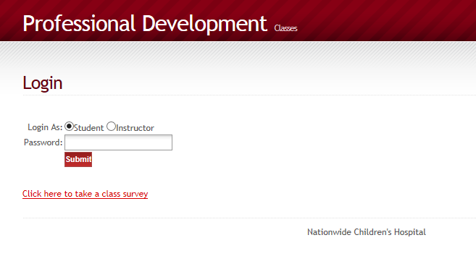

- To access the correct survey, fill out the fields with the appropriate information. A student name is not required. You should find your instructor’s name in the drop down list. For precepted students, select “Staff Preceptor” as your instructor. In the application box, select “Clinical Experience – Schools of Nursing.” Select the unit where the majority of the clinical was experienced. All four rows must be completed to access the survey. Click on the link: Take Survey/Evaluation.

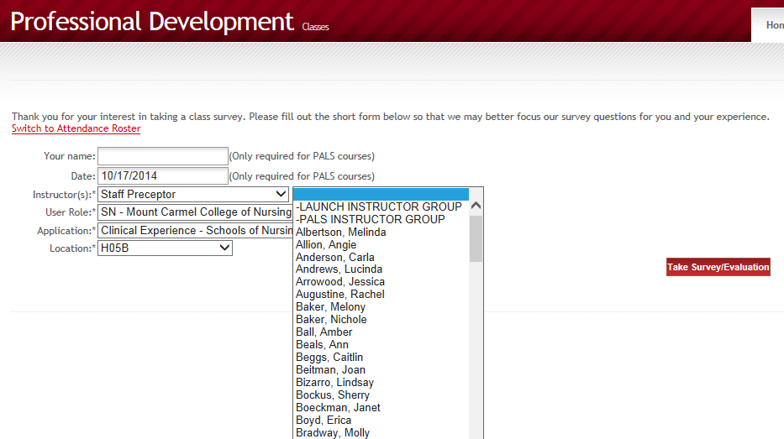

- Use the bulleted numbers to respond to each objective, with 1 being the lowest and 5 being the highest. Add additional comments as needed. When you are finished, you must click Submit Survey to save.
