Nationwide Children's:Nationwide Children’s Authentication

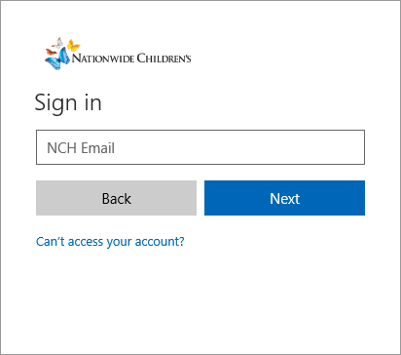
Site and Log In
Log in using your NCH email and password.

Additional Security Measures
Additional security verification is necessary for your first log in.
      - Click the Set it up now button on the added security page.
      - Select Authentication Phone in the Step 1: How should we contact you?
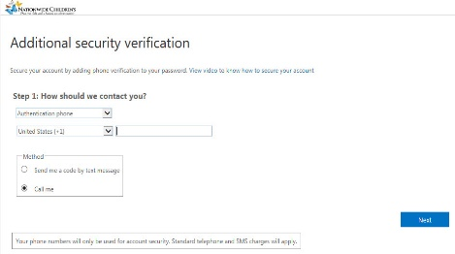
      - Select United States (+1) as the country.
2
3
4
56
6
      - Enter your phone number.
          - This phone should be with you at the time of verification for both internal and external.

      - Choose whether you want a phone call or a text message.
      - Click the Next button.
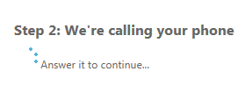
          - Step 2: We’re calling your phone screen displays.
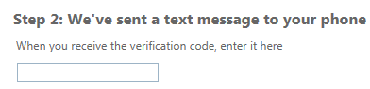
                - Microsoft initiates a call to the number provided. To validate press the # key on the phone.
          - Step 2: We’ve sent a text message to your phone screen displays.
                - A text message is sent to you with a code. Enter the code on the Step 2: screen.

      - The Step 2: screen displays “Verification successful!” once complete.
Note
There are many variations available for Step 1: How should we contact you?. The recommended solution is Authentication Phone.
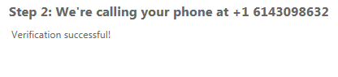
      - Click the Done button.
7

